**Python Functions**

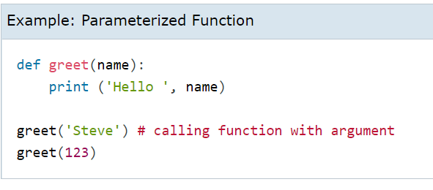

**OUTPUT:** hello Steve

hello 123

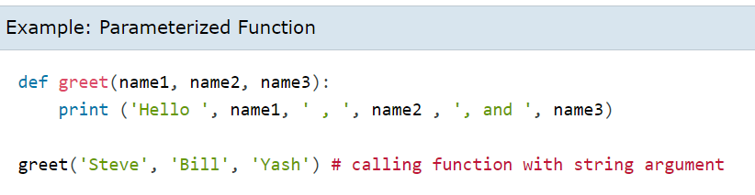

**OUTPUT:** hello steve , bill , and yash

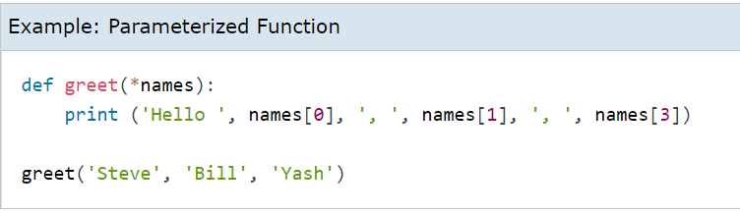

**OUTPUT:** hello steve , bill , yash

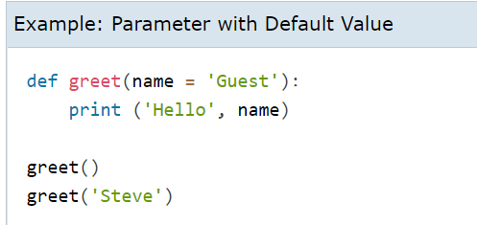

**OUTPUT:** hello guest

hello steve

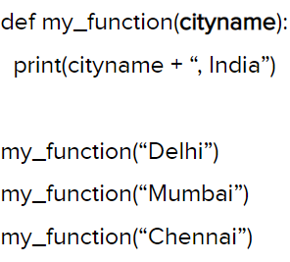

**OUTPUT:** delhi,India

mumbai,India

chennai,India

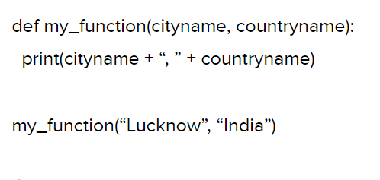

**OUTPUT:** lucknow,India

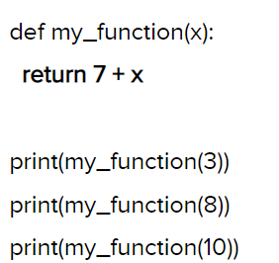

**OUTPUT:** 10

15

17

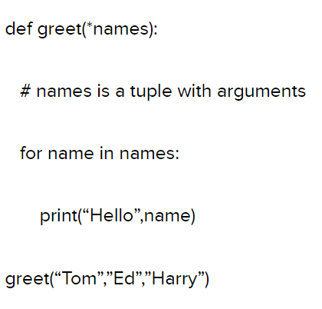

**OUTPUT:** hello tom

hello ed

hello harry

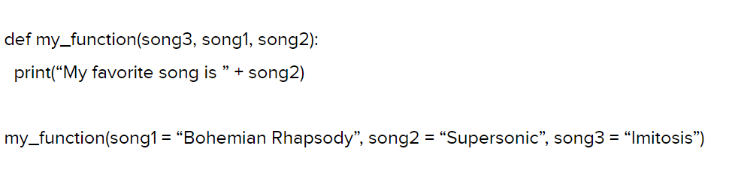

**OUTPUT:** my favourite song is def

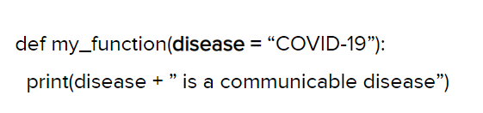

**OUTPUT:** covid19 is a communicable disease

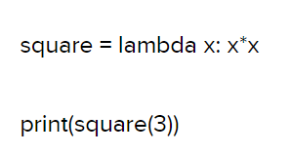

**OUTPUT:** 9

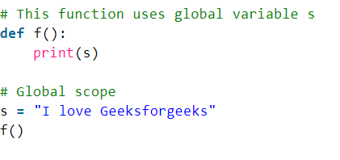

**OUTPUT:** I love greeksforgreeks

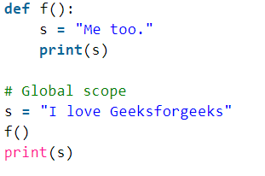

**OUTPUT:** me too.

I love greeksforgreeks

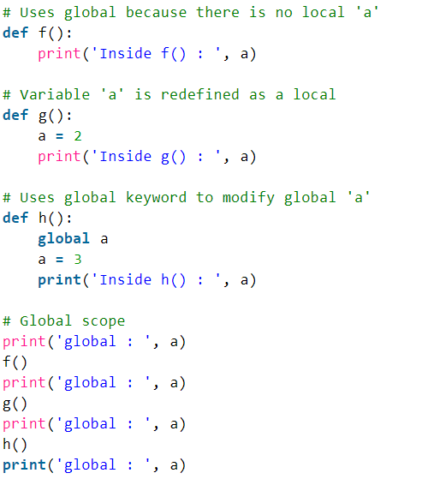

1. Write a Python function to sum all the numbers in a list. Sample List : (8, 2, 3, 0, 7) Expected Output : 20

**Code:** def sum(numbers):

total = 0

for x in numbers:

total += x

return total

print(sum((8, 2, 3, 0, 7)))

**OUTPUT:** 20

1. Write a Python function to multiply all the numbers in a list. Sample List : (8, 2, 3, -1, 7) Expected Output : -336

**Code:** def multiply(numbers):

total = 1

for x in numbers:

total *= x

return total

print(sum((8, 2, 3, -1, 7)))

**OUTPUT:** -336

1. Write a program to create function func1() to accept a variable length of arguments and print their value.

Hint:

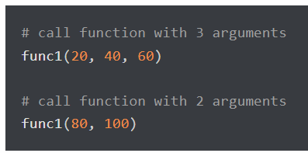

Expected output:

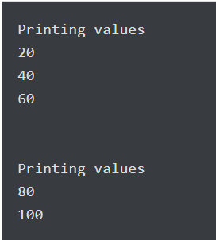

**Code:** def func1(*args): **Output:** 20

for i in args: 40

print(i) 60

func1(20, 40, 60) 80

func1(80, 100) 100

4. Write a program to create function calculation() such that it can accept two variables and calculate addition and subtraction. Also, it must **return both addition and subtraction in a single return call**.

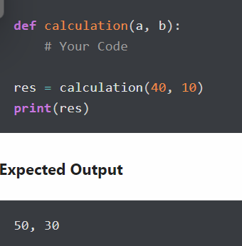

**Code:** def calculation(a, b):

addition = a + b

subtraction = a - b

return addition, subtraction

res = calculation(40, 10)

print(res) **Output:** 50 30

5. Write a program to create a function show_employee() using the following conditions.

* It should accept the employee’s name and salary and display both.
* If the salary is missing in the function call then assign default value 9000 to salary

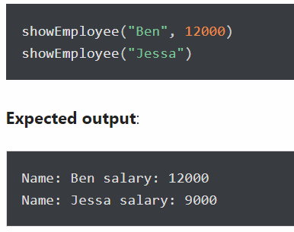

### Code: def show_employee(name, salary=9000):

### print("Name:", name, "salary:", salary)

### show_employee("Ben", 12000)

### show_employee("Jessa")

**Output:** Name: Ben salary: 12000

Name: Jessa salary: 9000

### 6. Assign a different name to function and call it through the new name

### Below is the function display_student(name, age). Assign a new name show_tudent(name, age) to it and call it using the new name.

### 

### Code: def display_student(name, age):

### print(name, age)

### display_student("Emma", 26)

### showStudent = display_student

### showStudent("Emma", 26)

### Output: Emma 26

### Emma 26

### 7.

### 

### 8.

### 9.